CST 229 – Lecture 5
Wilsonville, Fall 2017

Ch 14-15, PDA, deterministic vs. non, CFG = PDA

Pushdown Automata
Enhanced FA, by adding a limited memory
- Alphabet Σ of input letters
- Input tape (infinite), containing input string of letters in Σ, followed by blanks
- Alphabet Γ of stack characters
- Pushdown stack, containing letters in Γ, initially empty
- Finite number of states, one of which is the starting state, of following types:
  - Accept state: Machine halts and string accepted
  - Reject state: Machine halts and string rejected
  - Push X state: Push letter X onto stack and transition unconditionally
  - Pop state: Pop letter from stack and use to evaluate next transition
  - Read state: Read letter from tape and use to evaluate next transition

Blank characters are represented by Δ. After the input string, the tape contains Δ infinitely. If the stack is empty, then a pop retrieves Δ. Transitions from Read or Pop states can be marked with Δ to indicate that it should transition if the read is past the end of the string or the stack is empty.

Note that the machine can halt with either accept or reject, even if the stack is not empty and the input tape still has letters.

What would be the PDA for the following language? (pg 295)
L = {a^{n}b^{n}, where n = 0, 1, 2…}

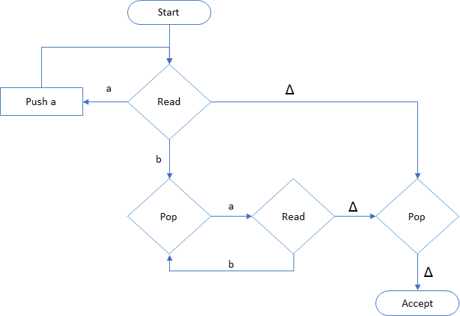

How about Palindrome? How would we construct a PDA to recognize this? (pg 302)

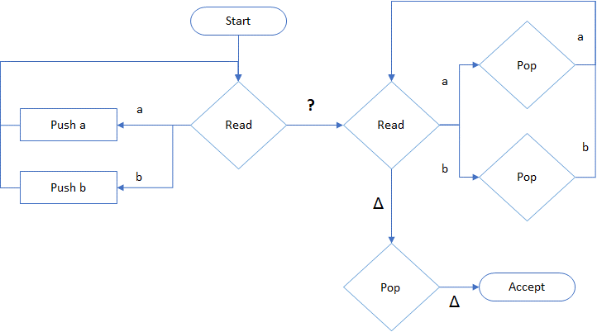

How do we know when to stop reading in the 1st half and switch to validating the 2nd?

Deterministic vs. Non-deterministic PDAs
N-PDAs can accept more languages than D-PDAs!

CFG = PDA
For every CFG, there is an PDA that will accept it, and vice-versa.

We can construct an PDA for any CFG…
- The stack alphabet consists of the non-terminals and terminals
- The tape alphabet consists of the terminals
- Start goes to Push of initial non-terminal
- Then to a Pop that has transitions for non-terminals of two types…
  - To Read states, if the production’s right hand side is only a terminal
  - To Push states, if the production’s right hand side has non-terminals (push the symbols on the reverse order they appear in the production)
- If the Pop finds the stack empty then a Read checks to ensure no more input, and then transitions to a final Accept

This is a non-deterministic PDA if there is more than one production for any non-terminal.

This machine simulates a “top-down” parse of the input sentence based on the CFG.

For example…

S → S + S | S * S | id

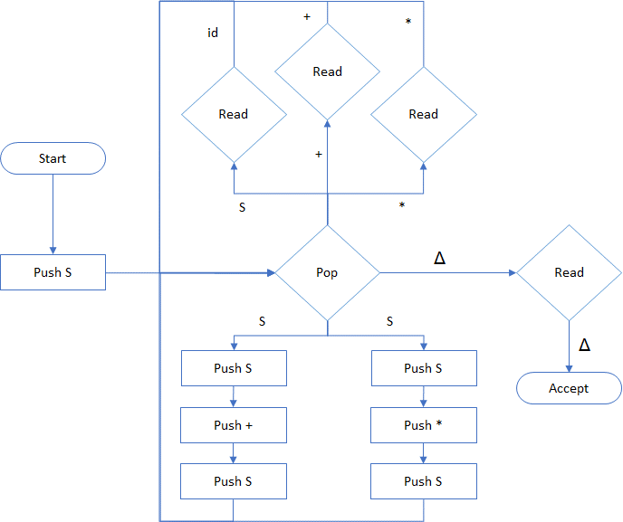

Note the three choices for which direction to go when Pop encounters an ‘S’ non-terminal
The upper-left path corresponds to the rule S→id
The two lower paths correspond to the rules S→S+S and S→S*S
Try processing the sentence “id + id * id” and experiment with which path to choose.

